Christopher J. Orton
After wowing audiences in Spamalot, actor Christopher Orton is now preparing for a very different role – that as a writer. As he prepares for his new drama to be launched, he tells Emily Lambert about the collaboration
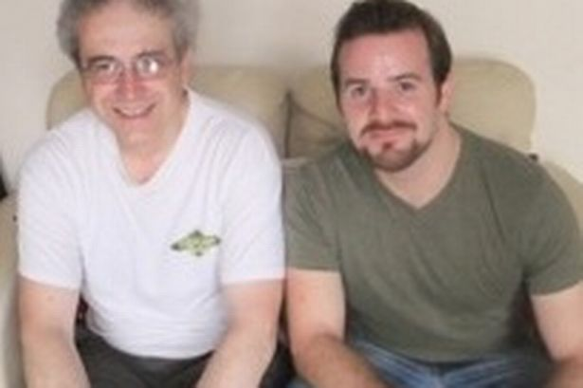
Robert Gould and Christopher Orton
THE immortal John Cleese line – “And now for something completely different” – will certainly ring true for actor and writer Christopher Orton this month. For he will swap performing in Monty Python’s Spamalot to watching his own play being staged. The Road To Port Of Barry was co-written by Orton and Robert Gould and is the opening work in the eighth year of director Michael Kelligan’s widely acclaimed On The Edge project of script-held performances of plays by mainly Welsh and Wales based authors. It is the latest collaboration between the two men who have penned a number of plays in the past.
Under his stage name of Kit Orton, Chepstow-born Orton made his West End debut in July in the role of Lancelot in Spamalot but he has been touring with the production for two years. For the successful spin-off from the movie Monty Python And The Holy Grail has toured extensively. Orton returns to his native Wales to watch the performances of his latest play straight after the end of the latest West End run. “I have been performing in Spamalot for the last two years and I didn’t think it was possible to top the buzz of going out and performing comedy to different audiences every night and soaking in the laughs and the enjoyment of the crowd,” he says. “That was until I heard something I had written being performed by someone else. There is nothing more flattering than somebody picking up your work and putting their own interpretation on it or getting excited by the content and trying things out with it – and then hearing the audience reaction becomes something else entirely because you helped create that mood in them.”
Together Orton and Gould have written a number of musicals, including Elephant Juice, Grace Notes, Based On A True Story and My Land’s Shore. In addition to The Road to the Port Of Barry, Gould and Orton have also collaborated on the plays Independence Dai and The Shed. Orton believes they complement each other with their working methods. “I am first and foremost a musician so writing music comes very naturally to me, not so much with script,” he says. “So when I’m writing musicals with Bob he will write the script and lyrics and I will write the music. “Writing plays together is a different pot of coffee… I’m more of an ideas man so I will ring Bob with a story suggestion or setting or tiny idea and then by the next day Bob will have written an outline and then we will send emails back and forth until we get it how we want it. “Being an actor it is sometimes difficult for me to take a backseat. I want to be up there doing it! So watching The Road To Port Of Barry will be a mixed bag of emotions. “It’s a real labour of love for the both of us. We have wanted to see this piece on the stage for a long time. I always thought I would have to be in it for that to happen but I am happy to be in the audience this time. Watching these extremely talented guys taking on the material.”
Since training at the Royal Northern College of Music and the Royal Academy of Music, Orton has built up a long list of theatre credits and has appeared at various concert and cabaret venues in London, performing his own songs and other pieces of new musical theatre writing. Winner of the Welsh Musical Theatre Younger Singer of the World 2008, he has recorded vocals on three musical cast albums – Dracula, Spamalot and My Land’s Shore. Swansea University graduate Gould – a former teacher and author of school history books – wrote the book and lyrics for three musicals with composer Ty Kroll – Lovers, Alone And Vocalize! He also worked on The Dying Game, a musical which speaks for the victims of HIV/AIDS in Africa, and he wrote lyrics for the acclaimed Tim Prottey-Jones albums More With Every Line and Surrounded By The Sounds and is in the process of writing and developing the musical Roundabout with songwriter Joe Sterling. Gould says: “Chris and I were introduced in January 2006 by a mutual friend when I was looking at the time for a composer to collaborate on a show I had an idea for. “As it happens we’ve still not gotten around to writing that show together. In February 2006 Chris asked me to write some scenes around some songs he had written for a musical called Elephant Juice which we then work shopped at the Royal Academy. “Soon after that he asked me if I’d like to work with him on My Land’s Shore, a musical he had already been working on for around four years. Since then we’ve continued to develop My Land’s Shore together as well as writing Based On A True Story, a few other musicals and three short plays.”
Christopher J. Orton wrote the music & lyrics for “This Time Next Week” (a musical with a Book by Andre Paul Spring) and, in collaboration with Gareth Evans and Ian Lynn, composed music for “Dracula - the musical” (a concept album of which was released in 2006).
Together with librettist & co-lyricist Robert Gould, he has co-written the musicals “My Land's Shore”, “Elephant Juice“, “Based On A True Story” (a workshop production of which was presented at the Jermyn Street Theatre in January 2010), “Grace Notes” and "Flop!".
A Studio Cast recording of “My Land’s Shore” was released in February 2012 by SimG Records.
Kit Orton trained at the Royal Northern College Of Music and The Royal Academy Of Music. In July 2012 he made his West End debut as Sir Lancelot in "Spamalot" at the Harold Pinter Theatre. In March/April 2013 he will be performing the role of Jackson in the Howard Goodall/Melvin Bragg musical "The Hired Man" at the Mercury Theatre, Colchester and The Curve, Leicester, alongside fellow principals Julie Atherton & David Hunter.
His other performing credits include roles in the “Spamalot” UK tour; "Peter Pan" (Dublin); “The Hot Mikado“, “Martin Guerre” and “Spend Spend Spend” (all at the Watermill Theatre, Newbury); "Songs For A New World" (Freiburg, Germany).
He has also appeared at various concert and cabaret venues in London, performing his own songs and other pieces of new musical theatre writing.
He has recorded vocals on three musical cast albums - "Dracula", "Spamalot" and "My Land's Shore"- as well as on the album "Somewhere In My Mind - The Songs Of Joe Sterling".
In 2008 he won the accolade of Welsh Musical Theatre Young Singer Of The Year.
